Linear Regression

🔹 What is Linear Regression?
Linear Regression is the most fundamental algorithm in machine learning. It models the relationship between input features (X) and a continuous target variable (Y) by fitting a straight line.
The basic idea is to find the best-fitting straight line that predicts the target variable accurately.
Goal: Find the best-fitting straight line (in 2D) or hyperplane (in higher dimensions) that predicts the output variable (Y) based on input features (X).

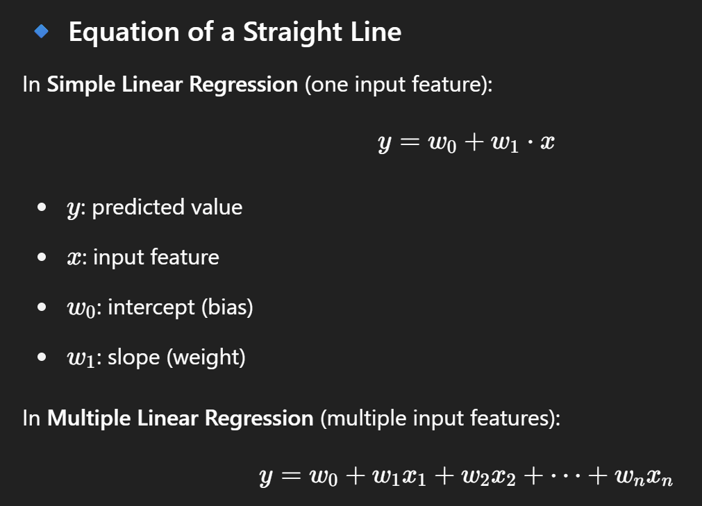
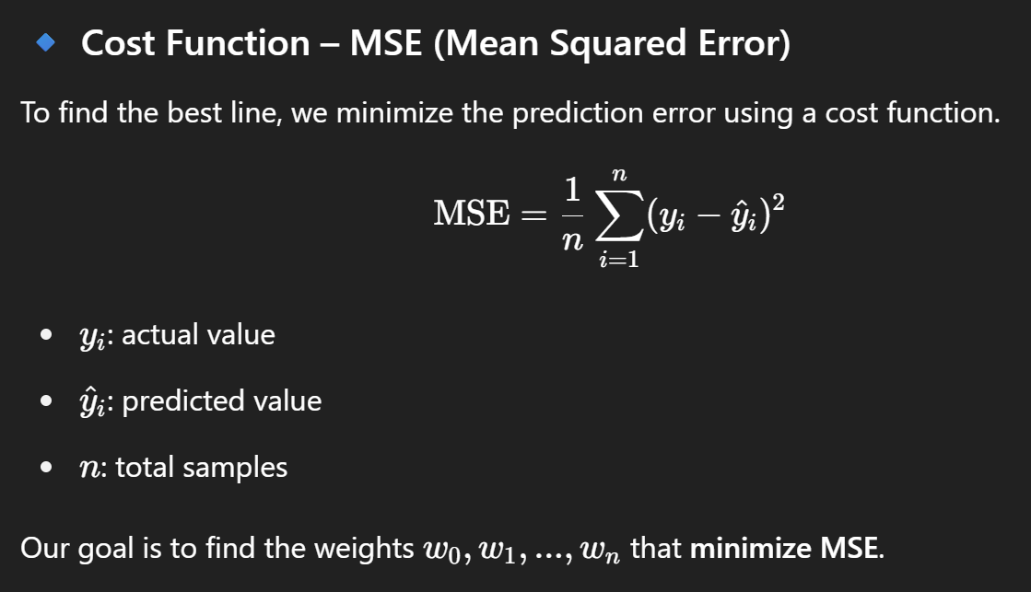
🔹 4. Optimization – Gradient Descent
Idea:
Gradient Descent is an iterative algorithm used to minimize the cost function by updating the parameters w and b in the opposite direction of the gradient.
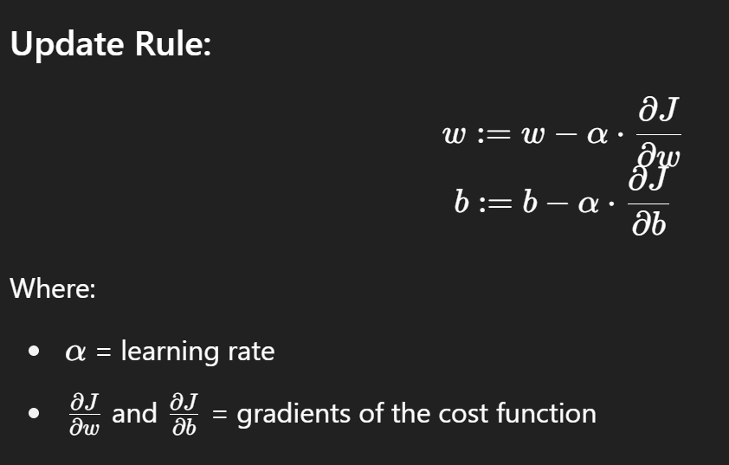
🔹 5. Interpretation of Parameters
- Weight (w): Represents the rate of change in prediction with respect to the input.
- Bias (b): Adjusts the output irrespective of the input.

🔹 6. Assumptions of Linear Regression
- Linearity: Relationship between X and Y is linear.
- Independence: Observations are independent.
- Homoscedasticity: Constant variance of error terms.
- Normality of Errors: Residuals should be normally distributed.

